
HANLEY CASTLE HIGH SCHOOL

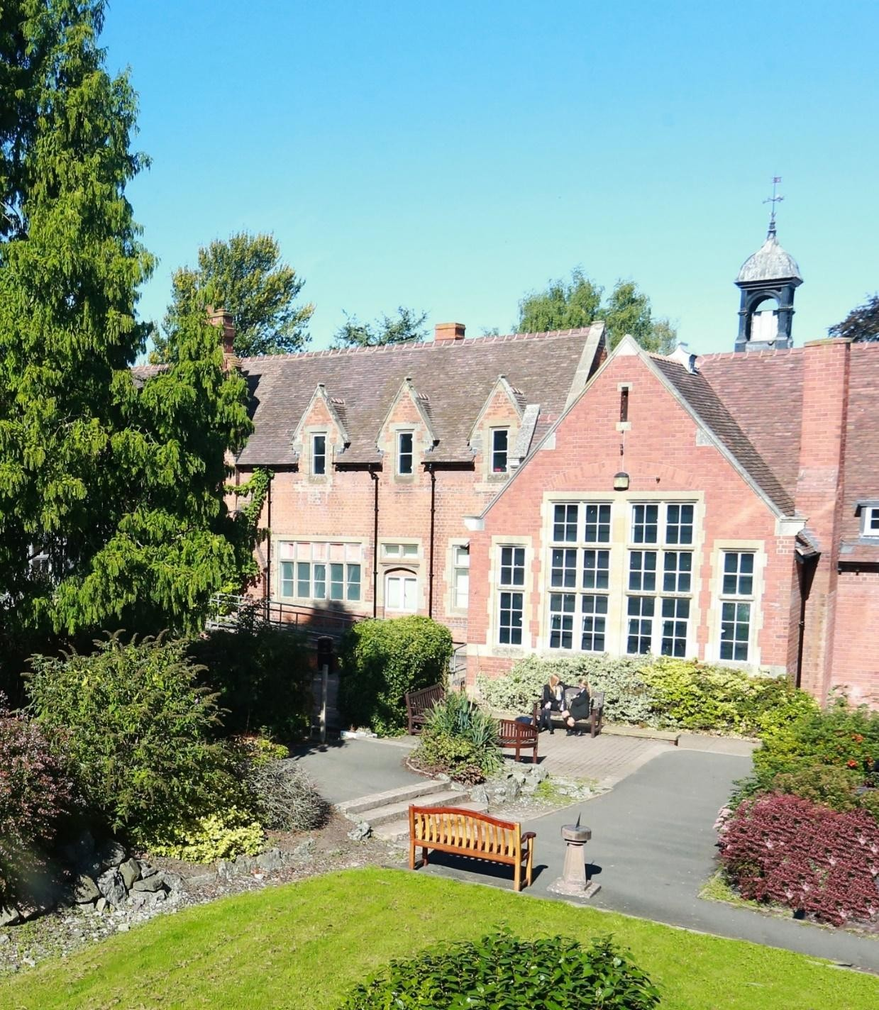
CHILD ON CHILD ABUSE POLICY
SEPTEMBER 2025

Review Frequency: | Annually | Date of Next Review: | September 2026
Date Reviewed: | September 2025 | Staff responsible: | Sarah Anderson-Kirby
Date Approved by ASC: | September 2025



Contents

- Context and definition 4
- Responsibility 5
- Purpose of policy 5
- Framework and legislation 5
- Abuse and harmful behaviour 5
- Types of abuse 6
  - Physical abuse 6
  - Sexual violence and sexual harassment 6
  - Bullying 7
  - Online bulling 7
  - Sexting / sharing nude or indecent imagery 7
  - Initiation/hazing 8
  - Prejudiced behaviour 8
  - Teenage relationship abuse 8
- Expected staff action 8
- Recognising peer abuse 9
  - Taking action 9
  - Recording sexualised behaviour 9
  - Gather the facts 9
  - Consider the intent 10
  - Decide on your next course of action 10
  - Informing parents/carers 10
- Points to consider 10
  - What is the age of the students involved? 10
  - Where did the incident or incidents take place? 10
  - What was the explanation by all students involved of what occurred? 10
  - What is each of the student’s own understanding of what occurred? 11
  - Repetition 11
- Next steps 11
  - For the young person who has been harmed 11
  - For the young person who has displayed harmful behaviour 11
  - After care 12
- Preventative strategies 12
- Where to go for further information 16
- Appendix 1: Flowchart – sexual misconduct – sexual harassment 17
- Appendix 2: Flowchart – sexual misconduct – sexual violence 18
- Appendix 3: Flowchart – sexual misconduct – sexual violence – sexually inappropriate language 19
- Appendix 4: Flowchart – sexual misconduct – sexual assault 20

Context and definition

It is essential that all our staff understand the importance of challenging inappropriate behaviours between peers, many of which are listed below, that are actually abusive in nature. Downplaying certain behaviours, for example dismissing sexual harassment as “just banter”, “just having a laugh”, “part of growing up” or “boys being boys” can lead to a culture of unacceptable behaviours, an unsafe environment for children and in worst case scenarios a culture that normalises abuse leading to children accepting it as normal and not coming forward to report it. (KCSIE 24)

Those who work with children at Hanley Castle High School and Sixth Form Centre are advised to maintain an attitude of ‘it could happen here’ where safeguarding is concerned. When concerned about the welfare of a child, staff should always act in the best interests of the child.

Child on child abuse is behaviour by an individual or group, intending to physically, sexually or emotionally hurt others.
All staff should recognise that children are capable of abusing their peers. All staff should be aware of safeguarding issues from peer abuse including:
- bullying (including online bullying)
- physical abuse such as hitting, kicking, shaking, biting, hair pulling, or otherwise causing physical harm
- sexual violence and sexual harassment
- sexting (also known as youth produced sexual imagery or nudes/ dick pics); and
- initiation/hazing type violence and rituals.

This abuse can:
- Be motivated by perceived differences e.g. on grounds of race, religion, gender, sexualorientation, disability or other differences
- Result in significant, long lasting and traumatic isolation, intimidation or violence to the victim; vulnerable adults are at particular risk of harm.

Children or young people who harm others may have additional or complex needs e.g.:
- Significant disruption in their own lives
- Exposure to domestic abuse or witnessing or suffering abuse
- Educational under-achievement
- Involved in crime.

Stopping violence and ensuring immediate physical safety is the first priority of any education setting, but emotional bullying can sometimes be more damaging than physical. School staff, alongside their Designated Safeguarding Lead and Deputies, have to make their own judgements about each specific case and should use this policy guidance to help.

Responsibility
Our staff are aware of systems within their school or college which support safeguarding, and these should be explained to them as part of staff induction. This should include the:
- Safeguarding and Child protection policy (which should amongst other things also include the policy and procedures to deal with child-on-child abuse)
It also emphasises that the voice of the child must be heard.
‘Governing bodies, proprietors and school or college leaders should ensure the child’s wishes and feelings are taken into account when determining what action to take and what services to provide. Systems should be in place for children to express their views and give feedback.Ultimately, all system and processes should operate with the best interests of the child at their heart.’
Child on Child abuse is referenced in the Safeguarding and Child Protection Policy. The sensitive nature and specific issues involved with Child on Child abuse necessitate separate policy guidance.
At Hanley Castle High School and Sixth Form Centre we continue to ensure that any form of abuse or harmful behaviour is dealt with immediately and consistently to reduce the extent of harm to the young person, with full consideration given to the impact on that individual child’s emotional and mental health and well-being.

Purpose of policy
The purpose of this policy is to explore some forms of Child on Child abuse. The policy also includes a planned and supportive response to the issues.

Framework and legislation
This policy is supported by the key principles of the Children’s Act, 1989 that the child’s welfare is paramount. Another key document is Working Together, 2023, highlighting that every assessment of a child, ‘must be informed by the views of the child’. (Working Together, 2023) This is echoed by Keeping Children Safe in Education, 2025 through ensuring procedures are in place in schools and settings to hear the voice of the child.

Abuse and harmful behaviour
It is necessary to consider: -
- what abuse is and what it looks like
- how it can be managed
- what appropriate support and intervention can be put in place to meet the needs of theindividual
- what preventative strategies may be put in place to reduce further risk of harm.

Abuse is abuse and should never be tolerated or passed off as ‘banter’ or ‘part of growing up’. It Is important to consider the forms abuse may take and the subsequent actions required.
- Children are vulnerable to abuse by their peers. Such abuse should be taken as seriously as abuse by adults and should be subject to the same child protection procedures.
- Children can abuse other children. This can include (but is not limited to): abuse within intimate partner relationships; bullying (including cyberbullying); sexual violence and sexual harassment; physical abuse such as hitting, kicking, shaking, biting, hair pulling, or otherwise causing physical harm; sexting and initiation/hazing type violence and rituals.

- Staff should not dismiss abusive behaviour as normal between young people and shouldnot develop high thresholds before taking action.
- Staff should be aware of the potential uses of information technology for bullying and abusive behaviour between young people.
- Staff should be aware of the added vulnerability of children and young people who have been the victims of violent crime (for example mugging), including the risk that they mayrespond to this by abusing younger or weaker children.
The alleged perpetrator is likely to have considerable unmet needs as well as posing a significant risk of harm to other children. Evidence suggests that such children may have suffered considerable disruption in their lives, may have witnessed or been subjected to physical or sexual abuse, may have problems in their educational development and may have committed other offences. They may therefore be suffering, or be at risk of suffering, significant harm and be in need of protection. Any long-term plan to reduce the risk posed by the alleged perpetrator must address their needs.

Types of abuse
There are many forms of abuse that may occur between children and this list is not exhaustive. Each form of abuse or prejudiced behaviour is described in detail followed by advice and support on actions to be taken.
  - Physical abuse
This may include hitting, kicking, nipping/pinching, shaking, biting, hair pulling, or otherwisecausing physical harm to another person. There may be many reasons why a child harms another and it is important to understand why a young person has engaged in such behaviour, including accidently before considering the action or punishment to be undertaken.
  - Sexual violence and sexual harassment
Sexual violence and sexual harassment can occur between two children of any age and sex. It can also occur through a group of children sexually assaulting or sexually harassinga single child or group of children.
Sexually harmful behaviour from young people is not always contrived or with the intent to harm others. There may be many reasons why a young person engages in sexually harmful behaviour and it may be just as distressing to the young person who instigates it asto the young person it is intended towards. Sexually harmful behaviour may include

    - inappropriate sexual language
    - inappropriate role play
    - sexual touching
    - sexual assault/abuse.
Staff should be aware of the importance of:
    - making clear that sexual violence and sexual harassment is not acceptable, willnever be tolerated and is not an inevitable part of growing up
    - not tolerating or dismissing sexual violence or sexual harassment as “banter”,“part of growing
up”, “just having a laugh” or “boys being boys”; and
    - challenging behaviours (potentially criminal in nature), such as grabbing bottoms, breasts and genitalia, flicking bras and lifting up skirts. Dismissing or tolerating such behaviours risks normalising them

    - Upskirting: where someone takes a picture under a person’s clothing (not necessarily a skirt) without permission and or knowledge, with the intention of viewing their genitals or buttocks (with or without underwear) to obtain sexual gratification, or cause the victim humiliation, distress or alarm. It is a criminal offence. Anyone of any gender, can be a victim.

  - Bullying
Bullying is unwanted, aggressive behaviour among school aged children that involves a realor perceived power imbalance. The behaviour is repeated, or has the potential to be repeated, over time. Both young people who are bullied and who bully others may have serious, lasting problems.
In order to be considered bullying, the behaviour must be aggressive and include:
    - An Imbalance of Power: Young people who bully use their power—such asphysical strength, access to embarrassing information, or popularity—to control or harm others. Power imbalances can change over time and in different situations, even if they involve the same people.
    - Repetition: Bullying behaviours happen more than once or have the potentialto happen more than once.
Bullying includes actions such as making threats, spreading rumours, attacking someone physically or verbally or for a particular reason e.g. size, hair colour, gender, sexual orientation, and excluding someone from a group on purpose.
  - Online bulling
Online Bullying is the use of technology (social networking, messaging, text messages, e-mail, chat rooms etc.) to harass threaten or intimidate someone for the same reasons as stated above.
Online bullying can take many forms
    - Abusive or threatening texts, emails or messages
    - Posting abusive comments on social media sites
    - Sharing humiliating videos or photos of someone else
    - Stealing someone’s online identity
    - Spreading rumours online
    - Trolling – sending someone menacing or upsetting messages through socialnetworks, chatrooms or games
    - Developing hate sites about another person
    - Prank calls or messages
    - Group bullying or exclusion online
    - Anonymous messaging
    - Encouraging a young person to self-harm
    - Pressuring children to send sexual messages or engaging in sexual conversations.

  - Sexting / sharing nude or indecent imagery
The term ‘sexting’ relates to the sending of indecent images, videos and/or written messages with sexually explicit content; these are created and sent electronically. Theyare often ‘shared’ via social networking sites and instant messaging services. These are known colloquially as ‘nudes’ or ‘dickpics’.
Upskirting: typically involves taking a picture under a person’s clothing without them knowing, with the intention of viewing their genitals or buttocks to obtain sexual gratification,or cause the victim humiliation, distress or alarm. It is a criminal offence. Anyone of any gender, can be a victim.

This must always be referred immediately to the Designated Safeguarding Lead DSL will follow the UKCIS: Sexting in schools and colleges 2016 guidance.
https://www.gov.uk/government/ uploads/system/uploads/attachment_data/file/551575/6.243 9_KG_NCA_Sexting_in_Schools_WEB 1_.PDF

  - Initiation/hazing
Hazing is a form of initiation ceremony which is used to induct newcomers into an organisation such as a private school, sports team etc. There are a number of different forms, from relatively mild rituals to severe and sometimes violent ceremonies. The ceremony welcomes newcomers by subjecting them to a series of trials which promote a bond between them. After the hazing is over, the newcomers also have something in common with older members of the organisation, because they all experienced it as partof a rite of passage. Many rituals involve humiliation, embarrassment, abuse, and harassment.

  - Prejudiced behaviour
The term prejudice-related bullying refers to a range of hurtful behaviour, physical or emotional or both, which causes someone to feel powerless, worthless, excluded or marginalised, and which is connected with prejudices around belonging, identity and equality in wider society – for example disabilities and special educational needs, ethnic, cultural and religious backgrounds, gender, home life, (for example in relation to issues ofcare, parental occupation, poverty and social class) and sexual identity.

  - Teenage relationship abuse
Teenage relationship abuse is a pattern of actual or threatened acts of physical, sexual, and/or emotional abuse, perpetrated by an adolescent (between the ages of 13 and 18) against a current or former partner. Abuse may include insults, coercion, social sabotage, sexual harassment, threats and/or acts ofphysical or sexual abuse. The abusive teen uses this pattern of violent and coercive behaviour, in a heterosexual or same gender relationship, in order to gain power and maintain control over the partner. This abuse may be child sexual exploitation.

Expected staff action
Staff should consider the seriousness of the case and make a quick decision whether to inform the designated Safeguarding Lead immediately before taking any further in-school actions. If the issue has been sexual misconduct-sexually inappropriate language then the member of staff should use the behaviour management policy and protocol and email for Duty Team. The incident will then be investigated and dealt with appropriately. If the issue is categorised as Sexual misconduct- Sexual harassment or Sexual violence then it is entered on CPOMS in the same way choosing the appropriate category and the Pastoral Office should investigate and apply appropriate sanctions.
If a member of staff receives information regarding sexual misconduct but does not witness it, then they should report it to the Pastoral Office with as much detail as possible. The Pastoral Office will then decide next steps which may include investigation and sanction.
All actions following a report of sexual misconduct should be recorded on CPOMS and the reporting member of staff informed of outcomes.

See Appendices 1-4

Recognising Child on child abuse
An assessment of an incident between peers should be completed and consider:
- Chronological and developmental ages of everyone involved
- Difference in their power or authority in relation to age, race, gender, physical, emotional or intellectual vulnerability
- All alleged physical and verbal aspects of the behaviour and incident
- Whether the behaviour involved inappropriate sexual knowledge or motivation
- What was the degree of physical aggression, intimidation, threatening behaviour orbribery
- The effect on the victim
- Any attempts to ensure the behaviour and incident is kept a secret
- The child or young person’s motivation or reason for the behaviour, if they admit that itoccurred
- Whether this was a one-off incident, or longer in duration
It is important to deal with a situation of peer abuse immediately and sensitively. It is necessary togather the information as soon as possible to get the true facts. It is equally important to deal with it sensitively and think about the language used and the impact of that language on both the children and the parents when they become involved. Avoid language that may create a ‘blame’ culture and leave a child labelled.
Staff will talk to the children in a calm and consistent manner. Staff will not be prejudiced,judgmental, dismissive or irresponsible in dealing with such sensitive matters.

  - Taking action

    - Always take complaints seriously
    - Gain a statement of facts from the student(s)
    - Assess needs of victim and alleged perpetrator
    - Consider referral to Police or Social Care
    - Contribute to multi-agency assessments
    - Convene a risk management meeting if necessary
    - Record all incidents and all action taken

  - Recording sexualised behaviour

    - Be clear, explicit and non-avoidant, and avoid vague statements or euphemisms
    - Record as soon as possible, as you can quickly forget or confuse detail
    - Follow the prompts on your safeguarding and child protection recording form
    - Use proper names for body parts but record exactly any language or vocabulary used by the child.
    - Use the child’s exact words in quotation marks.
    - Note where and when the incident happened and whether anyone else was around.

  - Gather the facts
Speak to all the young people involved separately, gain a statement of facts from them and use consistent language and open questions for each account. Ask the young people to tell you what happened. Use open questions, ‘where, when, why, who’. (What happened? Who observed the incident? What was seen? What

was heard? Did anyone intervene?) Do not interrogate or ask leading questions.

  - Consider the intent
Has this been a deliberate or contrived situation for a young person to be able to harmanother?

  - Decide on your next course of action
If you believe any young person to be at risk of significant harm you must report to the Designated
Safeguarding Lead immediately; they will follow the school’s Safeguarding andChild Protection Policy.
If MASH and the police intend to pursue this further, they may ask to interview the young people in school or they may ask for parents to come to school to be spoken to. It is important to be prepared for every situation and the potential time it may take.

  - Informing parents/carers
Parents will be informed of cases unless there is reason to believe that the child may be put at risk by doing so. The best way to inform parents is by a face to face though this may not always be possible or appropriate.
Is the pupil 13+ and does not want to share with parents? Use the ‘Gillick’ test and the‘Fraser’ guidelines.
NSPCC | Gillick competency and Fraser guidelines

In all circumstances where the risk of harm to the child is evident then the school should encourage the young person to share the information with their parent/carer (they may bescared to tell parents/carers that they are being harmed in any way).

Points to consider

  - What is the age of the students involved?
How old are the young people involved in the incident and is there any age difference between those involved? In relation to sexual exploration, children under the age of 5, inparticular 1-4 year olds who are learning toileting skills may show a particular interest in exploration at around this stage. This, however, should not be overlooked.

  - Where did the incident or incidents take place?
Was the incident in an open, visible place to others? If so, was it observed? If not, is more supervision required within this particular area?

  - What was the explanation by all students involved of what occurred?
Can each of the young people give the same explanation of the incident and also what isthe effect on the young people involved? Is the incident seen to be bullying for example, in which case regular and repetitive?

Is the version of one young person different from another and why?

  - What is each of the student’s own understanding of what occurred?
Do the young people know/understand what they are doing? E.g. do they have knowledge of body parts, of privacy and that it is inappropriate to touch? Is the young person’s explanation in relation to something they may have heard or been learning about that has prompted the behaviour? Is the behaviour deliberate and contrived? Doesthe young person have understanding of the impact of their behaviour on the other person?

  - Repetition
Has the behaviour been repeated to an individual on more than one occasion? In the sameway it must be considered has the behaviour persisted to an individual after the issue has already been discussed or dealt with and appropriately resolved?

Next steps
Once the outcome of the incident(s) has been established it is necessary to ensure future incidents of abuse do not occur again and consider the support and intervention required for those involved.
  - For the young person who has been harmed
The level of support required depends on the individual young person. It may be that they wish to seek counselling or one to one support via a mentor. It may also be that they feel able to deal with the incident(s) on their own or with support of family and friends; in which case it is necessary that this young person continues to be monitored and offered support should they require it in the future. If the incidents are of a bullying nature, the young person may need support in improving peer groups/relationships with other young people, or some restorative justice work with all those involved may be required.
Other interventions that could be considered may target a whole class or year group forexample a speaker on online bullying, relationship abuse etc. It may be delivered through the PSD and RSE curriculum.
If the young person feels particularly vulnerable it may be that a risk assessment can be put in place for them whilst in school so that they have someone named that they can talk to, support strategies for managing future issues and identified services to offer additional support.
  - For the young person who has displayed harmful behaviour
It is important to find out why the young person has behaved in such a way. It may be thatthe young person is experiencing their own difficulties and may even have been harmed themselves in a similar way. In such cases support such as one to one mentoring or counselling may also be necessary.
Particular support from identified services may be necessary through an early help referral and the young person may require additional support from family members.
Once the support required to meet the individual needs of the young person has been met, it is important that the young person receives a consequence for their behaviour. This may be in the form of restorative justice e.g. making amends with the young person they have targeted if this has been some form of bullying. In the cases of sexually harmful behaviour it may be a requirement for the young person to engage in one to one work with a particularservice or agency (if a crime has been committed this may be through the police

or youth offending service). If there is any form of criminal investigation ongoing it may be that this young person cannot be educated on site until the investigation has concluded. In which case, the young person will need to be provided with appropriate support and education elsewhere.
It may be that the behaviour that the young person has displayed may continue to pose a risk to others, in which case an individual risk assessment may be required. This should be completed via a multi- agency response to ensure that the needs of the young person and the risks towards others are measured by all of those agencies involved including the youngperson and their parents. This may mean additional supervision of the young person or protective strategies if the young person feels at risk of engaging in further inappropriate or harmful behaviour.
Hanley Castle High School may also choose a sanction as a consequence such as suspension or time in the Ready to learn room for a period of time to allow the young person to reflect on their behaviour.

  - After care
It is important that following the incident the young people involved continue to feel supported and receive help even if they have stated that they are managing the incident. The feelings of remorse, regret or unhappiness may occur at a much later stagethan the incident. It is important to ensure that the young people do not engage in any further harmful behaviour either towards someone else or to themselves as a way of coping(eg self-harm). Regular reviews with the young people following the incident(s) are imperative.

Preventative strategies
Child on Child abuse can and will occur on any site even with the most robust policies and support processes. It is important to develop appropriate strategies to proactively prevent Child on Child abuse.
This school has an open environment where young people feel safe to share information about anything that is upsetting or worrying them. There is a strong and positive PSD/RSHE curriculum that tackles such issues as prejudiced behaviour and gives students an open forum to talk things through rather than seek one on one opportunities to be harmful to one another. The school makes sure that ‘support and report’ signposting is available to young people.
Staff will not dismiss issues as ‘banter’ or ‘growing up’ or compare them to their own experiences of childhood. Young people are part of changing their circumstances and, through school council and pupil voice for example, we
encourage young people to support changes and develop ‘rules of acceptable behaviour’. We involve pupils in the positive ethos in school; one where all young people understand the boundaries of behaviour before it becomes abusive.
https://learning.nspcc.org.uk/media/1657/harmful-sexual-behaviour-framework.pdf

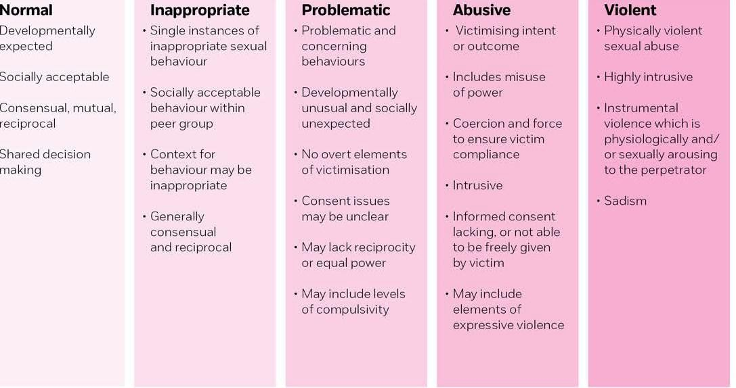

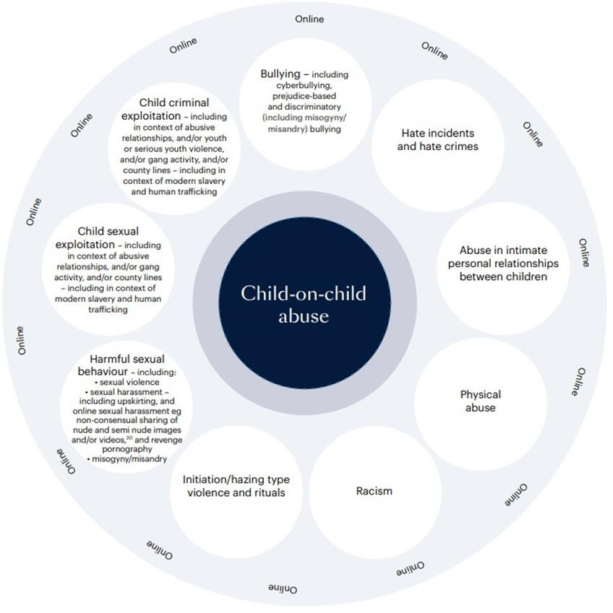

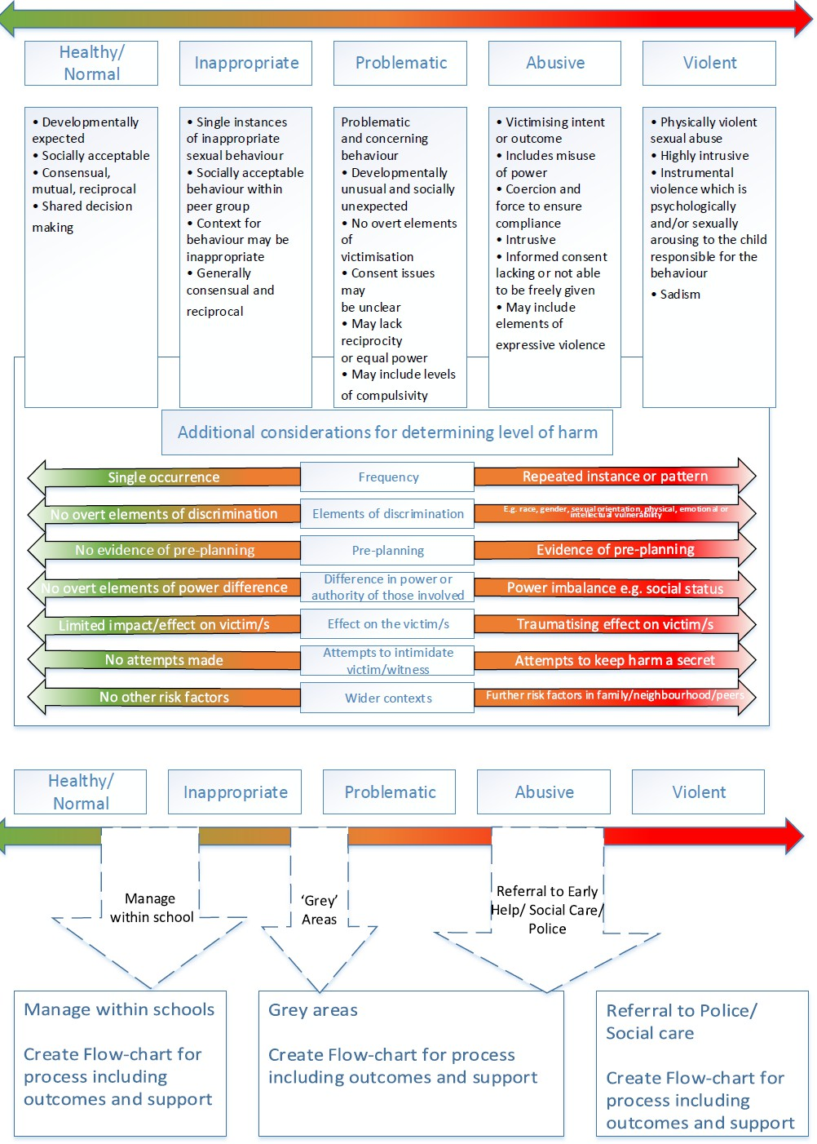

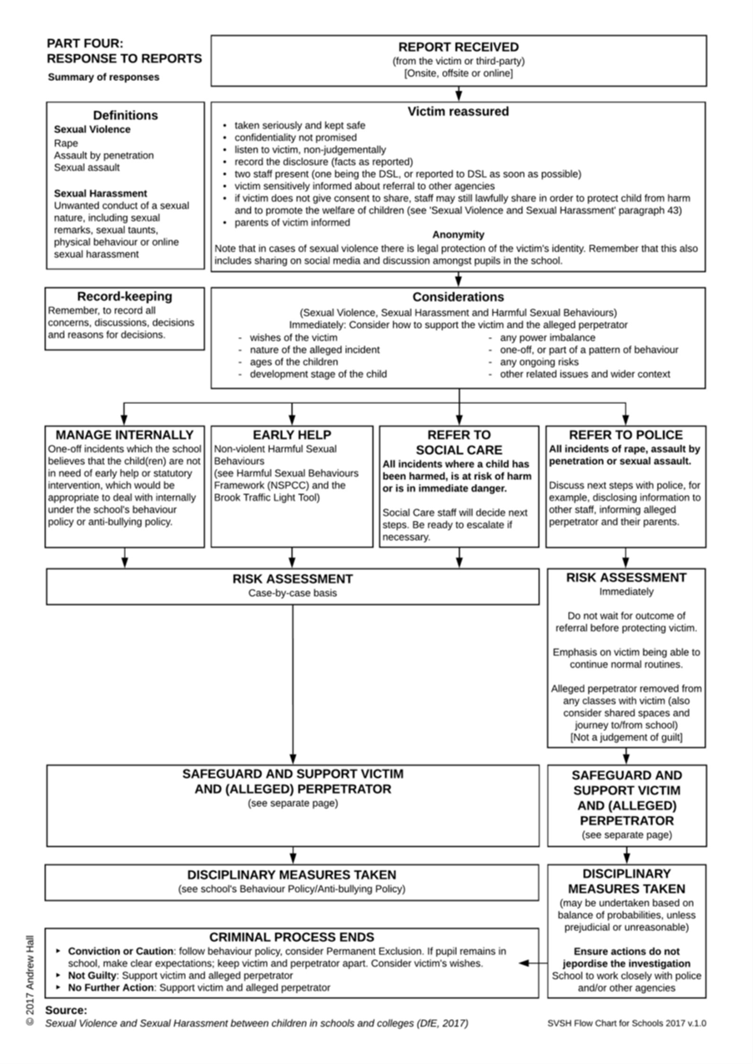

Where to go for further information
  - DfE: Statutory guidance: Working together to safeguard children, 2018
  - DfE: Searching, screening and confiscation at school, January 2018
  - Keeping_children_safe_in_education_2024.pdf
  - DfE: Preventing and Tackling Bullying, July 2017
  - DfE: Suspension and Permanent Exclusion guidance September 2023)
  - DfE: Teaching Online Safety in Schools
  - DfE: Behaviour in Schools - Advice for headteachers and school staff Feb 2024 (publishing.service.gov.uk)
  - DfE: Mental health and behaviour in schools, November 2018
  - DfE: Children Missing Education, September 2016
  - DfE: Mental health and behaviour in schools, November 2018
  - UKCIS: Sexting guidance for schools, 2016 (An updated copy of this guidance is due autumn term 2020)
  - Gov.uk: Equality Act 2010: advice for schools

Policy Log

Policy Name | Version | Date of Change | Summary of Changes | Reason for Change | Approved By
Child on Child Abuse Policy | September 2025 | 19.9.25 | Updated wording to incorporate new links | Updated DfE guidance | SAK

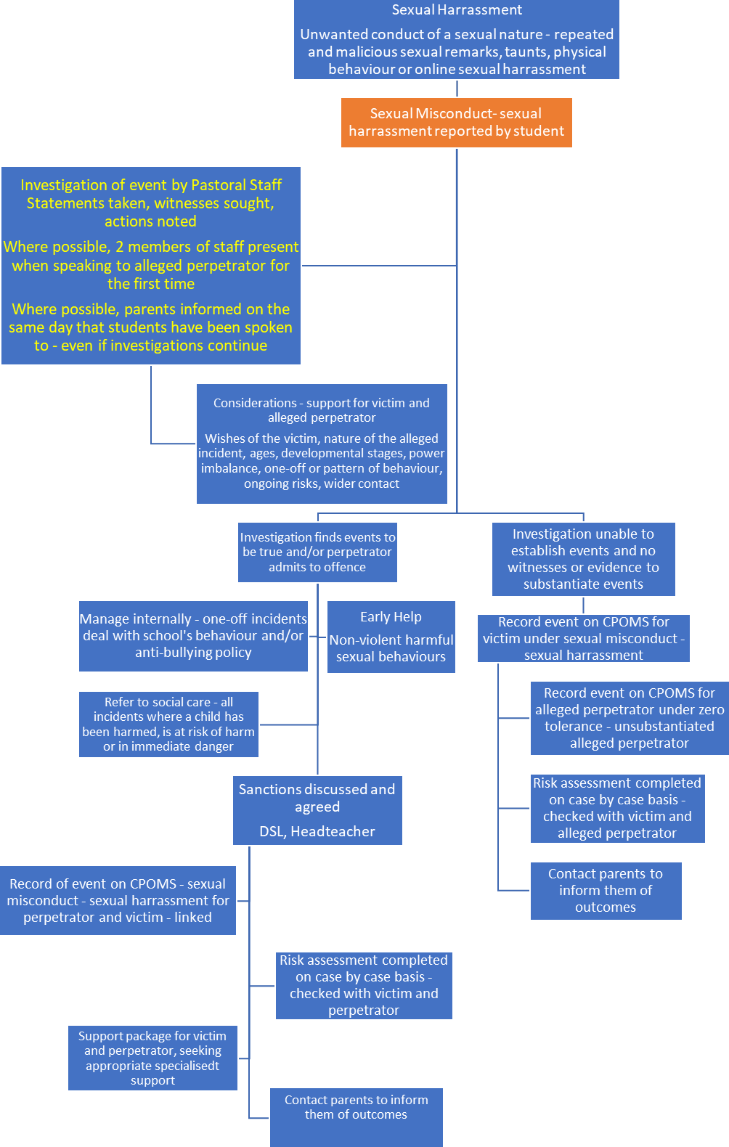
Appendix 1: Flowchart – sexual misconduct – sexual harassment
Examples:
Repeated online messages of a sexual nature – requesting images, sex Repeated touching – not friends Malicious, repeated name calling of a sexualised nature
Appendix 1 Flowchart – sexual misconduct – sexual harassment

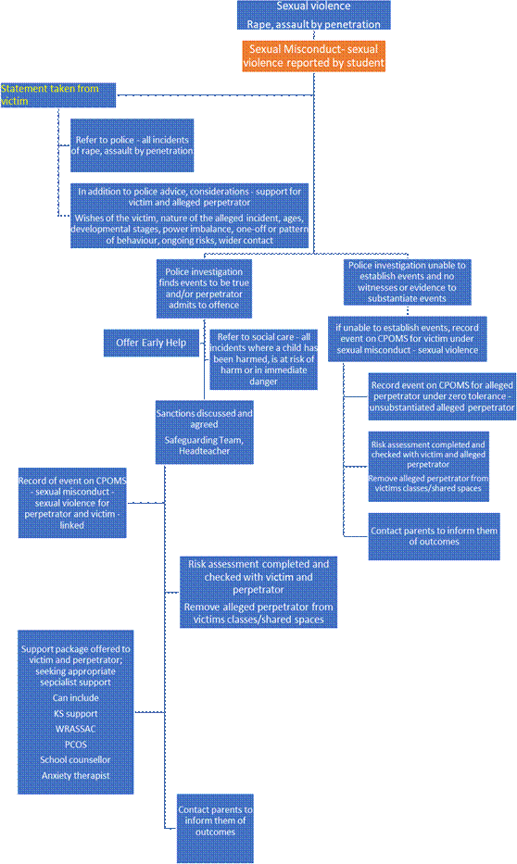
Examples:
Non-consensual finger penetration Rape

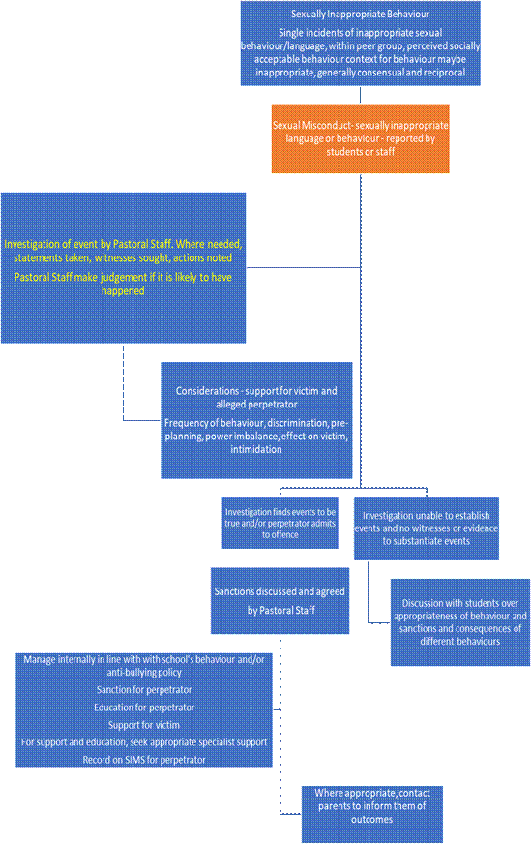
Examples:
Between friends, use of the term “slag”
Students in a relationship; one touches the others leg, is told to stop and does
Controversial debates
Use sexualised and graphic language Use of sexualised gestures

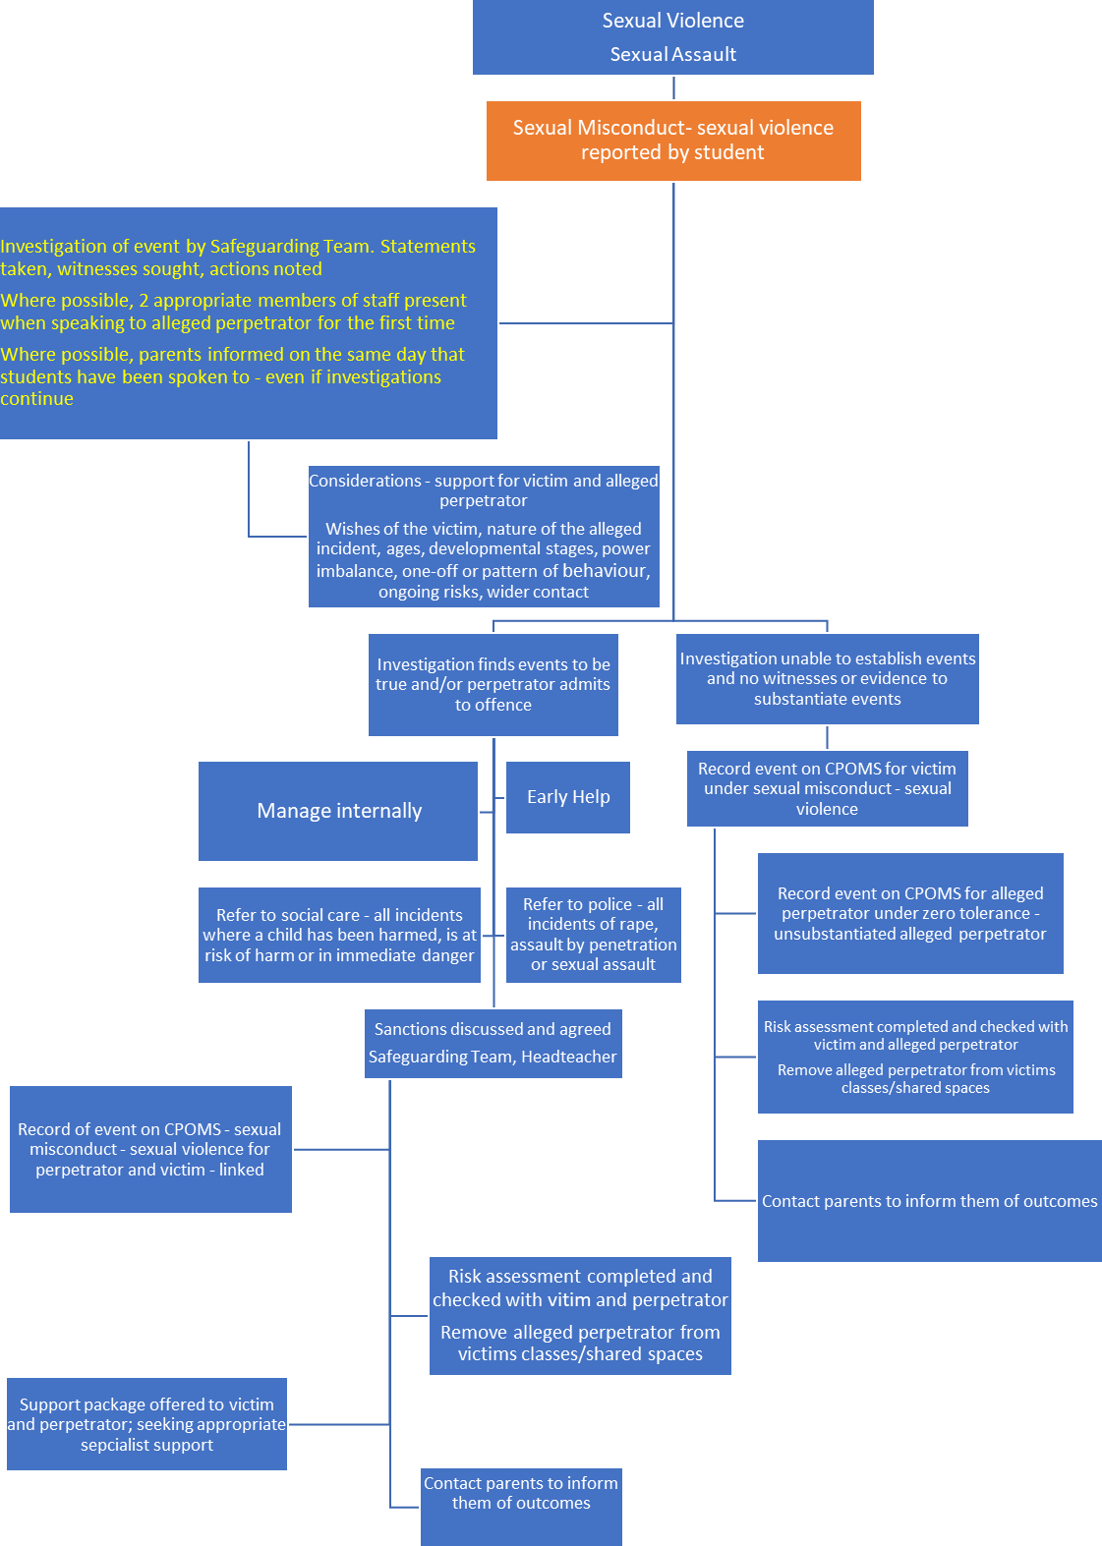
Examples:
Threat to assault by a student –
perceived as real.

