Frequently Asked Questions

When will I hear about my child’s progress?
You will receive A&Es before October half term. Year 11 Mocks take place at the beginning of December; results will be sent home mid-January. Following this, the Year 11 Parents Evening will be held in-person on Thursday 21st January (further details will be issued closer to the time). A final report will be sent home at the end of March, giving students final advice from their teachers in each of their subjects.

When will the real GCSEs be?
Provisionally, written GCSEs will be taken between 10th May and 18th June. There will be a contingency date at the end of the exam series in case of any unplanned disruption on a particular day – Wednesday 23rd June. GCSE results day is confirmed as Thursday 19th August 2027.

When are the mock exams?
The written Year 11 mock exams will run from Monday 30th November – Friday 11th December. The exam timetable will be sent home as soon as it is finalised. This will be the final opportunity for students to get used to preparing for and taking formal exams before the summer. It is important for teachers and students to measure current attainment against GCSE criteria and to identify any gaps. In the unlikely event of a summer exam series being cancelled by the government, mock exam performance will be used to help award grades.

What happens if my son/daughter is absent from their mocks?
In order to replicate the true experience of an external exam series and a true reflection of the students’ ability, we expect 100% attendance for year 11 mock exams. Any mock exams that are missed will not be re-sat unless a slot is found within the same exam series timetable.

How much revision should my son/daughter be doing?
Students should be completing up to 2 hours of revision per night, with additional revision completed at weekends. Homework set during this time will be guided revision. The amount of revision should build towards up to 3 hours per night by the summer term. The best investment of revision time is to start early and secure habits. Last-minute ‘cramming’ is a risky and ineffective approach. A useful strategy is to use a weekly planner, where fun/essential activities are included first – paid work, sports clubs, music lessons, seeing friends, with revision planned around those activities. Students will be given a revision planner to help them manage their time. Students need to practice applying their knowledge as well as learning facts.

How can I help my teenager revise?

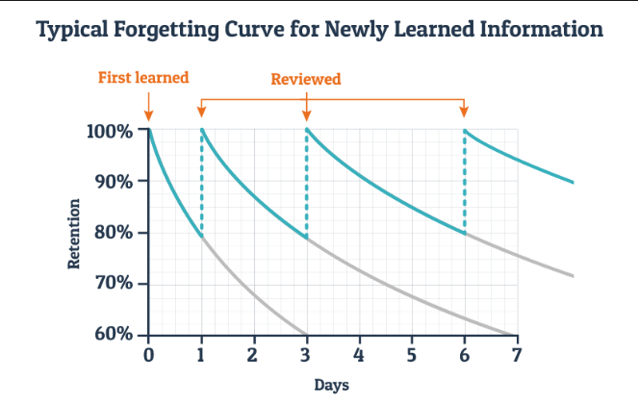
To retrieve information from our long-term memory, we need practice and strategies that work. Regular practice results in students being able to retain considerably more information.

Revision ‘strategies’ to avoid – the following strategies are “popular” but they have been proven to have low impact: re-reading notes, highlighting, revising the easy bits! They do not help commit information to the long-term memory.

Instead, use these Revision strategies – they do work:
Self-quizzing: this is one of the most effective strategies to learn and embed key knowledge. It works well with knowledge organisers and lists of definitions. Read – cover – write – check. Sometimes, reading out load helps to focus attention.
Blurting: this is an active recall strategy where students actively retrieve information from their memory. They write everything they know about a topic before checking for accuracy. Whiteboards are great for this. They then focus on the areas they found hard, cover their note and blurt again. Keep going until they feel secure in their knowledge retrieval. This is intense, so do it in short bursts and take breaks.
Past paper questions: using these is vital. Initially, use notes and only complete 1-2 questions at a time; gradually rely less on notes, attempting more questions in one go. It should be hard – the struggle is needed to move the information into the long-term memory.

Flashcards: these work best when they’re quick to use and focused. Write one fact or idea per card and test yourself regularly. Mix up the order and spend more time using the cards than making them.
Do:
- Sort cards by how well you know them and review the tricky ones more often.
- Use different colours for subjects or topics.
- Test your memory, not just your reading.
- Keep practising until you can explain or apply the idea.
Don’t:
- Cram too much onto one card.
- Always revise in the same order.
- Avoid hard topics — they’re the ones that help you improve

Managing revision schedules:
Spaced (or distributed) practice means revising a topic several times over days or weeks, instead of cramming it all at once. This helps the brain remember information for longer.
Example 1: Instead of revising all of Science on a Sunday, spend 20 minutes a day on different Science topics through the week.
Example 2: After learning French verbs today, review them again two days later, then a week later, then just before the test.
Regular short sessions beat one big last-minute session every time.

It takes on average 66 days to form habits – which is important when considering supporting our teenagers to get into the habit of revising. Steps to help create a new habit include:
- Cue – make it obvious – agree a time and place for revision; agreed revision timetable
- Craving – make it attractive – Set rewards
- Response – make it easy – remove distractions; have a purposeful workspace
- Rewards – make it satisfying – see improvements, track progress; revision cards; long-term goals

When my teenager revises, their phone keeps pinging! What can I do?
There are some useful Apps that help to avoid procrastination and help focus attention. They are free to download and some block the use of websites for a given time (time allocated to studying).
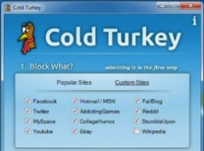
- FocusMe
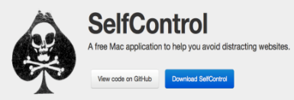
- Cold Turkey
- SelfControl
- F.lux/Night-Shift Mode

If my teenager is showing signs of stress, what advice can I give?

In addition to the following…
- Keep open channels of communication
- Problem solve with them
- Respect their friendships
- Plan enjoyable activities
- Encourage healthy habits
Other advice to give can include:
- Listen to calming music
- Try not to compare yourself to your friends

- Replace negative thoughts with positive thoughts such as: ‘this is just anxiety, it can’t harm me’ and ‘relax, concentrate - it's going to be okay’
- Keep perspective
- Plan revision – considering when you work best
- Start revising now to avoid last minute cramming
- Take short breaks - every 20-30 minutes
- Plan free time to unwind
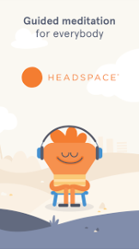
- Eat well and drink lots of water
- Keep active
- Try to get at least 8 hours sleep a night
- Allow half an hour or so to wind down before going to bed
- Tidy your bedroom and equip your desk
- Limit technology
- Download apps such as 1 Giant Mind or Headspace

How can I help my teenager during an exam series?

Once the exams start, it is likely to be a stressful time for your child. Your support will really help them through this. Some tips on how to make this go smoothly are below.
- Remain positive
- Support early revision
- Pick your battles
- Help them be prepared
- Keep to routines
- Wish them luck
- Ask how it went – without requiring a post-mortem
- Restrict technology
- Use their revision material to test them

How can I help my teenager on the morning of an exam?

At the start of each day, there will be nerves. Students may need support to leave the house fully equipped and ready for the exam.
- Know their timetable
- Allow time for brain to wake up - shower, eat breakfast
- Check structure of exam in advance
- Be well-equipped - spare pens, pencils. Check whether they need a calculator.
- Keep to the normal daily routine
- Remind them to visit the toilet
- Take water in (a bottle with a sports cap) - 70% better concentration when hydrated
How will my teenager be supported with their post-16 options?
All information regarding post 16 study at Hanley Castle 6th form can be found in the link below. Please encourage students to watch the subject and career pathway videos to help them think about their futures. Entry requirements for each subject can be found on a link next to each video. We hope that this will provide inspiration and motivation to work hard in the coming months.

Please book onto our 6th form open evening, which is on Thursday 26th November 2026, when a bespoke evening for every family will answer lots of questions about what to expect from level 3 studies at Hanley Castle Sixth Form.

https://www.hanleycastle.worcs.sch.uk/sixth-form/sixth-form-open-events/

In addition, Mr Holmes (Careers Lead) will meet with all year 11 students to support them with their post 16 options.

Please be reassured that students will have all the support that they need to make these important and exciting decisions.

When is the Prom?
The Year 11 Prom is going to be held on Thursday 1st July at Puckrup Hall Hotel, price to be confirmed – payment plans can be set up for this. Attendance to this special event is for students who show positive behaviour and work ethic in the build up to and during the exam period, including sitting all of their scheduled exams unless in case of extenuating circumstances.

How can I get in touch?
Email is the best way to get in touch with us. Contact details can be found on the school website: https://www.hanleycastle.worcs.sch.uk/contact-us/. If in doubt, contact the Year 11 Pastoral Team: Year11@hanleycastlehs.org.uk, or Mr Scanlan, Head of Year 11: scanlanm@hanleycastlehs.org.uk.

If you have any further questions that are not answered here, please contact us. Thank you.

IMPORTANT DATES

- Autumn Term - Year 11 Careers Interviews
- Thursday 26th November - Hanley Castle 6th Form Open Evening
- Monday 30th November - Friday 11th December - Year 11 Mock Exams
- Thursday 10th December - Hanley Castle 6th Form Applications Deadline
- Thursday 14th January - Year 11 Mock Results
- Thursday 21st January - Year 11 Parents Evening (in person)
- Thursday 25th March - Year 11 Advice sheets home
- Monday 10th May (provisional) - GCSEs start
- Wednesday 23rd June - Exam Contingency date
- Thursday 1st July – Year 11 Prom, Puckrup Hall Hotel
- Thursday 19th August – GCSE Results day

